Level-6

Final Project

Restaurant Rating

By

Gurmeet Singh

Table of Contents

Project Proposal 3

Goals and Objectives 3

Project Scope 3

Project Specifications 3

Target Audience 3

Project Deliverables 4

Resource Requirements 4

Project Tasks and Milestones 4

Project Assumptions 5

Project Report 5

Detail Design 6

Home Page 6

Login Page 6

Admin Registration Page 6

Admin Registered Restaurant Page 7

Admin Customer Page 7

Customer Ratings Page admin View 8

Customer Signup Page 9

Registered Restaurant Page Customer View 9

Project Testing 10

Usability Testing 10

Testing 10

User Manual 11

System Summary 12

System Configuration 12

User Access Levels 12

# 

# Project Proposal

## Goals and Objectives

The main goal of this project is to implement an online web application named Restaurant Rating System. With the help of this application customer can rate their favourite restaurants easily. In this ASP.net application there are two types of account admin and customer. Admin can register new restaurants, edit, delete and access the details as well. Admin can manage customer by editing, deleting and accessing their details. Admin can also access the details of the rating. Customer on the other hand can rate restaurants and access the details of the restaurant. Customer can also edit and access details of customer ratings. New Customer can signup for the application. Existing admin can register new admins for the web application.

## Project Scope

This is a 20 days project. The scope of this project is to build an online web application named Restaurant rating. Using this application customers can rate their favourite restaurants.

## Project Specifications

* Login by admin and customers.
* Register new restaurants, edit, delete and access details of existing ones by admin
* Admin can edit, delete and check details of the customers.
* Admin can check details of the rating of the restaurant.
* Customer can rate restaurant and access details of the restaurants.
* Customer can edit and access details of customer rating.

## Target Audience

The audience for this project will be the people who loves to eat food and encourage the places from where they can get yummy food and would like to promote their restaurants. Age group can start from 7 and can go up to 100 plus.

## Project Deliverables

Following table states the deliverables for the project:

|  |  |
| --- | --- |
| **Deliverable** | **Description** |
| Final Report | This will be the final complete report of the project |
| Coding | All the code of the project will go in this part. |
| Documentation | This will show how the application will run and the user manuals |
| Testing | This part will highlight the test details of the project. |

## Resource Requirements

Following technologies and development method:

* Identity framework- ASP
* Microsoft word processor.
* Windows Operating System
* Asp.net MVC Framework
* 64-bit Processor and 8 GB or more RAM

## Project Tasks and Milestones

The table below shows the Project Tasks and Milestones

|  |  |
| --- | --- |
| **Weeks** | **Tasks** |
| 1 | Brainstorming and Research |
| 1 | Planning and meeting & Consultation  proposal documentation. |
| 1 | Database Design- Plan and Implementation |
| 2 | Identity framework Implementation |
| 2 | Coding- Admin Part |
| 2 | Coding – Customer part |
| 3 | Testing |
| 4 | Final Documentation |

## Project Assumptions

* One admin and user exist while the App is designed and implemented.
* Admin and customer need to have valid credentials.
* Only admin can add new admin and manage the customer of the application
* The app will be open sources and user friendly.

# Project Report

#### Functional and Non-Functional

|  |  |  |
| --- | --- | --- |
| Users | Functional | Non- Functional |
| Admin | * Login/Logout * Manage restaurant registration * Edit, delete and check details of the customers. * Can check details for rating. | The non-functional requirements of the project are:   * The project will run on all browsers and devices. * The project will be secure * The load time will be fast * Admin will have full access of the system. * Customer will have limited access of the system. |
| Customer | * Login/Logout * Sign up * Can view and edit rating * Can view restaurant rating. * Can do restaurant rating. |

## Detail Design

### Home Page

This is the main landing page of the application. On the navigation menu there are- home, restaurant rating, Customer Signup, login and create ratings admin.

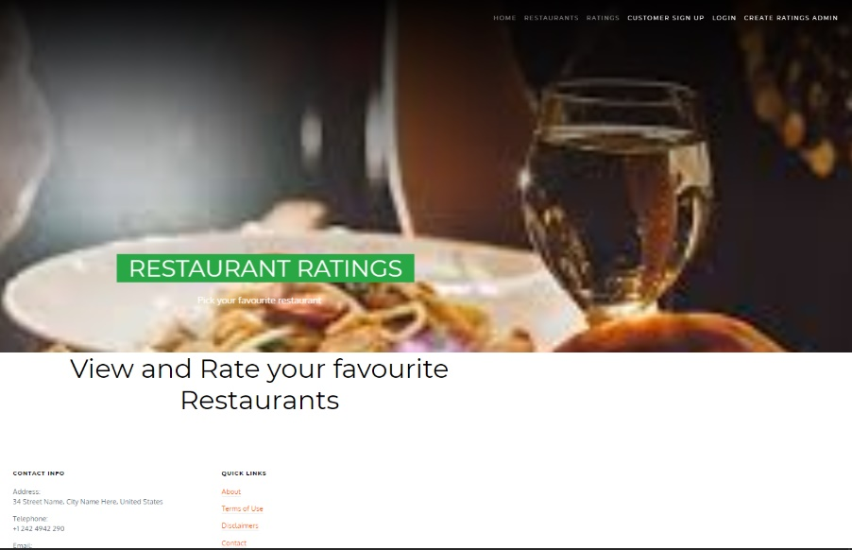

### Login Page

With the help of this page registered admin and customer can login to the system by using their valid credentials.

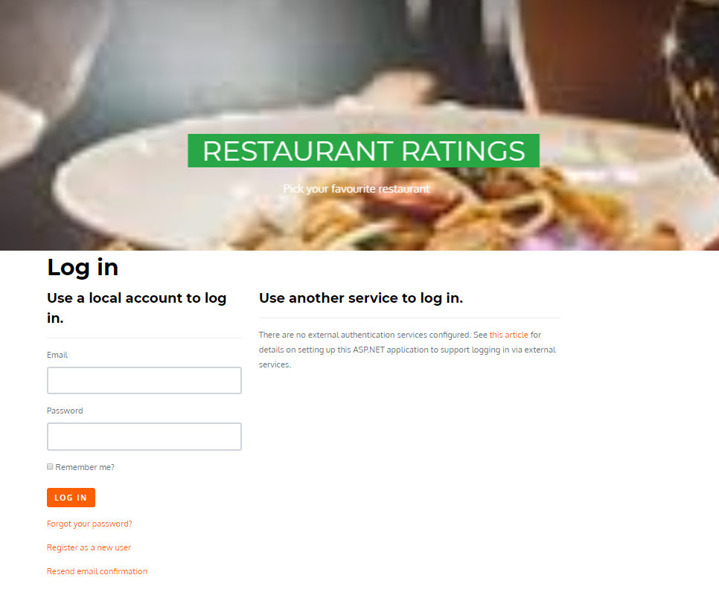

### Admin Registration Page

With the help of this page existing admin can register new ones.

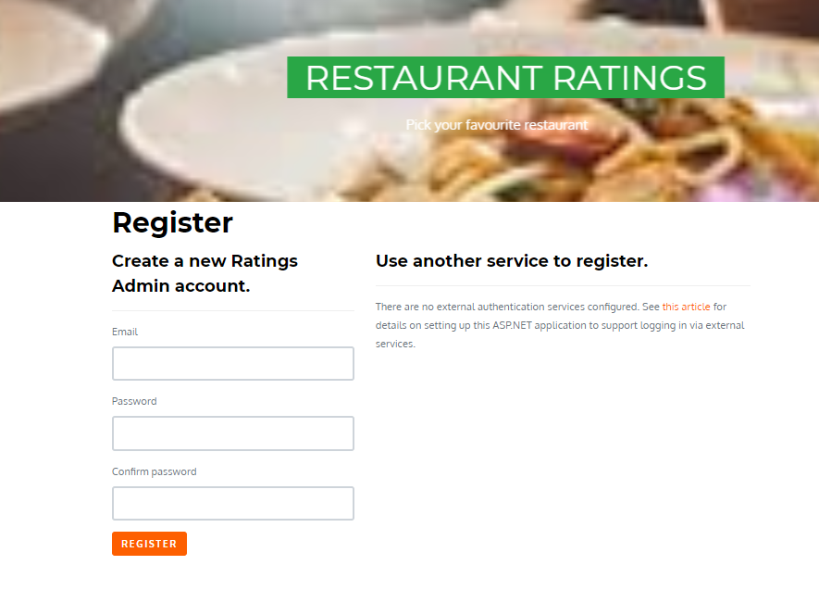

### Admin Registered Restaurant Page

With the help of this page, admin can register new restaurants, edit, delete and access details of the existing ones.

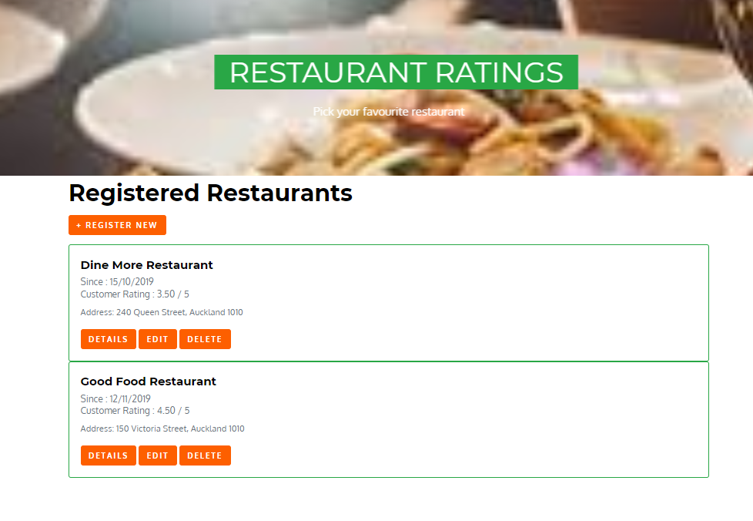

### Admin Customer Page

This page helps the admin to edit, delete and check the details of the customers.

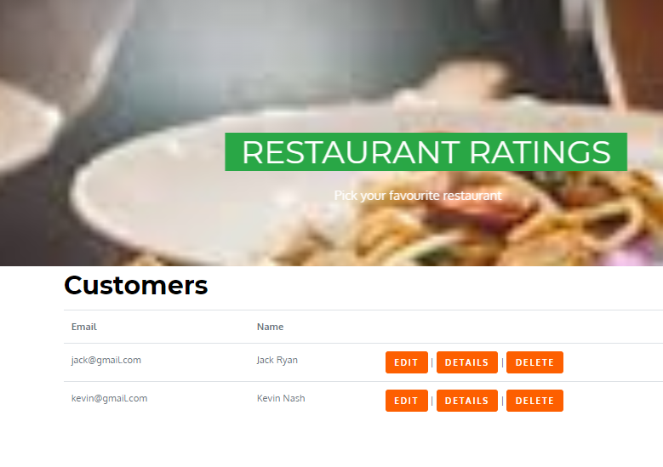

### Customer Ratings Page admin View

On this page admin can view the details of the rating given by customer.

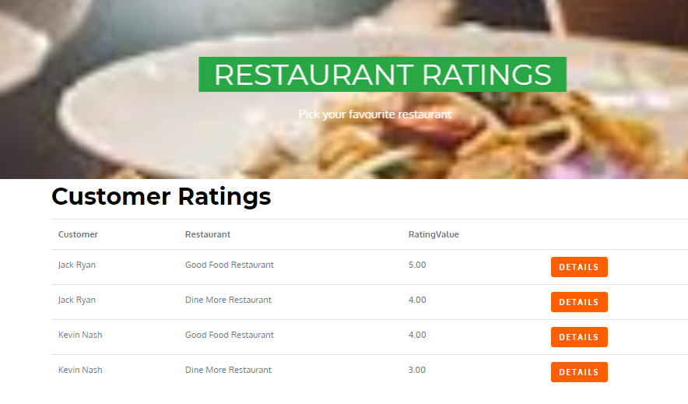

### Customer Signup Page

With the help of this page, new customer can sign-up for application.

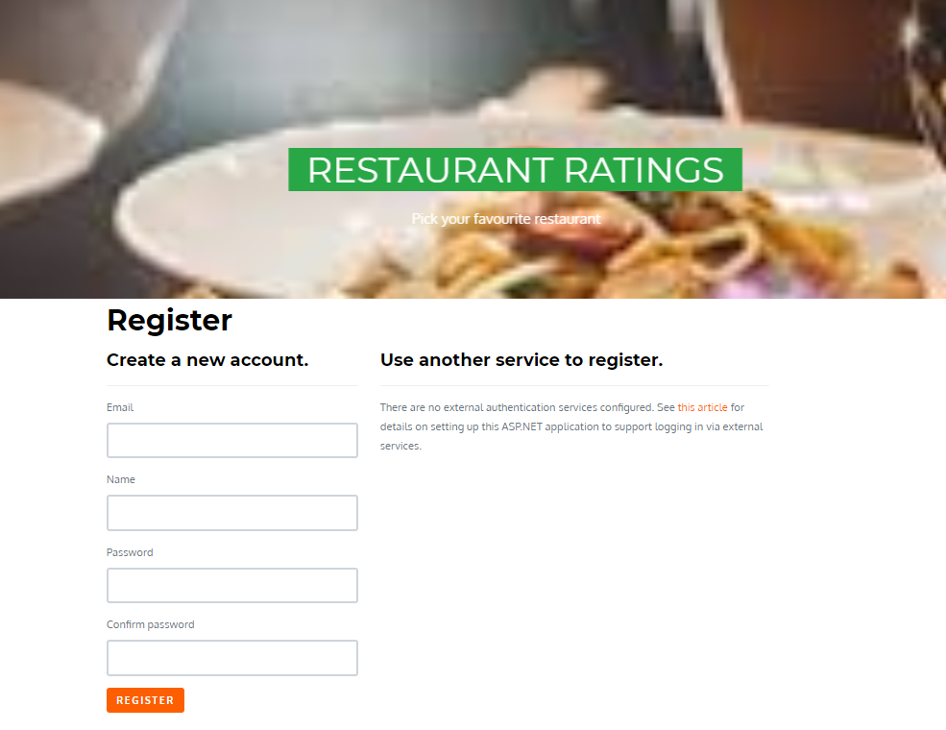

### Registered Restaurant Page Customer View

With the help of this page customer can rate the restaurant and access the details of the registered restaurant.

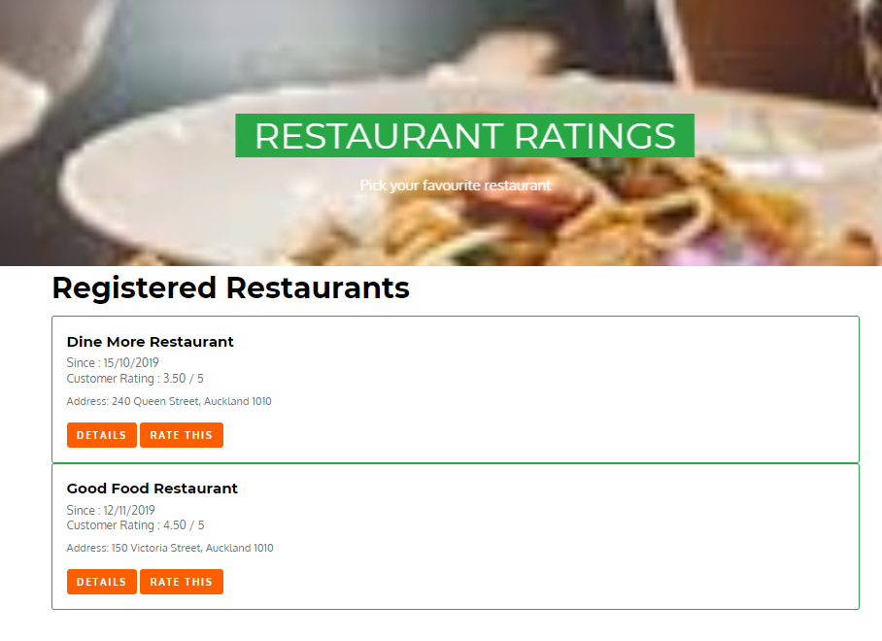

Customer Rating Page

With the help of this page customer can edit and access the details of the restaurant rating.

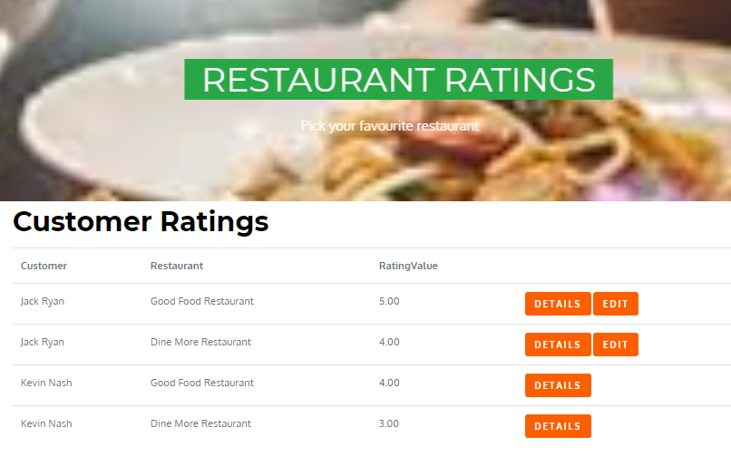

# Project Testing

## Usability Testing

### Testing

**Tester 1**

|  |  |  |
| --- | --- | --- |
| **Tester – 1** | | **Scale** |
| **No.** | **Question** | **Good, very good, bad, neutral,** |
| 1 | Do you think you need the support of a technical person to use this system? | Good |
| 2 | Is there any inconsistency? | Very Good |
| 3 | Is system easy to use? | Good |
| 4 | I would like to use this system daily | Bad |
| 5 | Integration is good | Neutral |
| 6 | I found the system complicated | Good |
| 7 | I think most people would learn to use this system very quickly | Neutral |
| 8 | I found the system very challenging to use | bad |
| 9 | I can feel confident while running the system | Good |
| 10 | Lot of knowledge is required to run the system | Neutral |

**Tester 2**

|  |  |  |
| --- | --- | --- |
| **Tester – 2** | | **Scale** |
| **No.** | **Question** | **Good, very good, bad, neutral,** |
| 1 | Do you think you need the support of a technical person to use this system? | Good |
| 2 | Is there any inconsistency? | Good |
| 3 | Is system easy to use? | Good |
| 4 | I would like to use this system daily | Good |
| 5 | Integration is good | Neutral |
| 6 | I found the system complicated | Good |
| 7 | I think most people would learn to use this system very quickly. | Good |
| 8 | I found the system very challenging to use | Neutral |
| 9 | I can feel confident while running the system | Good |
| 10 | Lot of knowledge is required to run the system | Neutral |

# User Manual

With the help of Restaurant Rating System application customer can rate their favourite restaurants easily. In this ASP.net application there are two types of account admin and customer. Admin can register new restaurants, edit, delete and access the details as well. Admin can manage customer by editing, deleting and accessing their details. Admin can also access the details of the rating. Customer on the other hand can rate restaurants and access the details of the restaurant. Customer can also edit and access details of customer ratings. New Customer can sign-up for the application. Existing admin can register new admins for the web application.

## System Summary

### System Configuration

The Restaurant Rating application will help customer to rate their favourite restaurants.

### User Access Levels

Only registered users can access the features of Job Advertisement application

* **Admin:** Full access to the system and all functionalities.
* **Customer:** All customer can have limited access to the functionalities.